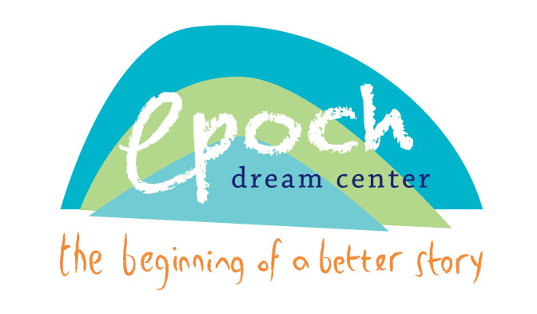

Epoch Summer Enrollment Form - Summer 2022

Student’s Name: ____________________________________________________________________________________
Last First Middle
Date of Birth: ____________________________________ Age: ___________________
Physical Address: ___________________________________________________________________________________
Race:__________________________________________ Ethnicity: __________________________________________
Parent/Guardian Name & Phone Number:
Name: _____________________________________________________ Relation: _______________________________
Home Phone: ______________________ Work Phone: ______________________Cell Phone: _________________________
Name: _____________________________________________________ Relation: _______________________________
Home Phone: _______________________ Work Phone: ______________________Cell Phone: _________________________
Others authorized to assume care for your child and/or pick up your child if you cannot be reached: See attached form.
At the end of the day, my child will: (circle one)
walk home (lives within town limits) or be a car rider
Epoch Permission
I give my child, _______________________________________, permission to:

- Attend field trips with an approved Epoch Dream Center volunteer or staff person. My child has permission to ride in the volunteer/staff member’s car or Epoch van to and from the destination. I also give the Epoch Dream Center volunteer/staff member permission to seek medical care to my child if needed.
- My child has permission to participate in religious activities of the program.
- I give permission for Epoch staff to photocopy report cards, progress reports, IEP’s and teacher correspondence. I understand that the Epoch Dream Center’s staff will be contacting my child’s teacher throughout the year as well as keeping records of my child’s report card as a way of tracking my child’s academic performance, behavior, and attendance. I give permission for administrative staff and evaluators to have access to my son/daughter’s grades, permanent record, attendance record, discipline record, and test scores, as well as any Department of Juvenile Services records. In doing so, I understand that the program, program staff and program evaluators will be privileged to confidential information about my son/daughter.
- I give permission and understand that my child or I may be photographed or videotaped and give my permission for the use of such photos or video for the promotion of the Epoch Dream Center and other organizations that partner with the Epoch Dream Center.
- My child has permission to participate in the Epoch Mentoring Program and meet with a mentor once a week. The form currently on file with the Epoch Dream Center is still applicable.
- As the parent or legal guardian of said child, I hereby consent for my child to attend and participate in all activities provided by the Epoch Dream Center.
- I give permission for my child to ride in a staff member, mentor, or volunteer’s car when being picked up or brought to/from home/school/Epoch when needed.

Signed: ______________________________________________________ Date: ____________________________ (Signature of Parent or Guardian)

Authorized Child Pick-Up Summer 2022

In order to protect your child and ensure their safety, we are asking that you provide a list of authorized adults that your child may assume care for your child in the case that you (parent/guardian) are unable to be reached in an emergency AND who may pick your child up from the Epoch Dream Center if you are unable to do so. Please know that your child will NOT be allowed to leave with anyone unless they are listed on this form. Changes to this list can be made in writing and in person. In the case that someone other than the authorized adults listed have to pick up your child, please send a written note with your child. ONLY in the case of an emergency may verbal consent be given.

Please let the authorized individual know that photo identification may be required at pick up.

I, __________________________________________________ give the following individuals permission to assume care for my child and/or pick up my child if I am unable to do so.
I understand that my child will NOT be allowed to leave the Epoch Dream Center with anyone other than those listed below:

Name Relation Phone #

1. |  | Home
 |  | Cell
2. |  | Home
 |  | Cell
3. |  | Home
 |  | Cell
4. |  | Home
 |  | Cell

____________________________________ _______________
Parent/Guardian Signature Date

EPOCH DREAM CENTER PARTICIPANT AGREEMENT, RELEASE, AND ASSUMPTION OF RISK
Please read this document carefully. It must be signed by a parent or legal guardian of a minor participant enrolled in the Epoch Dream Center. Parent or guardian is referred to in this agreement as “parent”.
In consideration of the services of the Epoch Dream Center, I, the undersigned parent of a minor participant (for himself or herself and, to the maximum extent allowed by the laws of Maryland, on behalf of the minor participant) in an activity of the Epoch Dream Center, acknowledge and agree as follows:
Activities and Risks: I understand that the Epoch Dream Center experience may involve activities and interactions that are new to my child and/or myself. I understand that these activities include, but are not limited to swimming, various sports, transportation in vehicles and field trips. These experiences come with certain risks and uncertainties beyond what I, or my child, may be accustomed to at home. These are activities that involve the risk of personal injury and even death, and loss or damage to property. I understand that the Epoch Dream Center activities occur in diverse areas, on or near water and subject to weather conditions that may cause harm. Participants may slip and fall resulting in strains, sprains and broken bones and suffer from exposure to extreme weather.
I realize that no environment is risk-free and that other risks will be encountered. I, and my child if applicable, understand the importance of abiding by Epoch rules, and I, or my child and I both agree that he or she will obey Epoch rules and the rules of the group’s leaders.
Assumption of Risks: I am aware of the risks of the Epoch Dream Center activities. I understand that Epoch cannot safeguard against all such injuries, and I expressly acknowledge and assume all the risks of the Epoch activities, inherent and otherwise, and whether or not described above.
Release and indemnity: As a parent on behalf of my minor child who is a participant in the Epoch Dream Center’s activities, my spouse, my other children, my parents, my heirs, assigns, personal representatives and estate, hereby agree to release and not to sue, and to indemnify, Epoch Dream Center, its directors, officers, agents, volunteers, mentors, employees, Nelson’s UMC and any federal, state or local agencies which have jurisdiction over lands or properties upon which the Epoch Dream Center programs operate (the Released Parties) with respect to any claim of liability, settlement, judgment, award or cost of defense and attorneys’ fees, including negligence, (but not gross negligence) arising from my, or my child’s enrollment or participation in an activity of the Epoch Dream Center.
Indemnity: I further agree to indemnify (that is, protect and pay, including costs and attorneys fees) the Epoch Dream Center and other Released Parties from any and all claims, including those brought by the child, a member of his or her family, a co-participant or any other person, arising out of injuries or other losses suffered by the child or caused by the child, and which are in any way connected with the child’s enrollment or participation in an activity of the Epoch Center.
Other: I agree to fully disclose all physical, mental and emotional conditions that could impact the safety or success of the program or cause me or my child to be a danger to him/herself or to others. I authorize the staff and volunteers of the Epoch Dream Center to provide or obtain such medical information for my child as they deem appropriate and to exchange medical information with third party care givers.
I agree that any dispute or cause of action arising between me or the child and any Released Party, arising from this agreement or otherwise, may be brought only in a court of competent jurisdiction located in Wicomico County, Maryland and shall be construed in accordance with the substantive laws of Maryland. In addition, I understand and agree to the Terms of Agreement as stated in this waiver.
I authorize and agree to the use by the Epoch Dream Center of any and all photographs and other images and statements by, of, or about me or my child, as deemed suitable by the Epoch Dream Center, without compensation.
I agree to be responsible for and agree to reimburse the Epoch Dream Center for loss of or willful destruction by me or my child of any equipment belonging to the Epoch Dream Center. The Epoch Dream Center will not be responsible for my or the child’s possessions which may become lost or stolen while I, or he/she, is engaged in an activity of the Epoch Dream Center.
The duration of this agreement is one year from the date of its being signed, if not sooner expressly cancelled or replaced in writing.

PARENT'S OR GUARDIAN'S ADDITIONAL INDEMNIFICATION- Today’s Date: ________________________________

(Must be completed for participants under the age of 18)

Student Name: ______________________________________________ Student’s date of birth: _______________________

By printing & signing your name below, you agree that you have read, understood and agree to this entire document.

Printed Name: _______________________________________ Signature: __________________________________________

Please list any medical/mental conditions, food allergies, and medications our staff should be aware of. _________________________________________________________________________________________________ _________________________________________________________________________________________________

